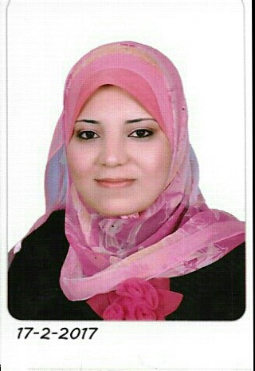

Personal Information

Full Name: Esraa Salah Ali Ismail.
Nationality: Egyptian.
Date and place of birth: 25th December, 1988, Egypt.
Home address: 9 Abo Bakr El-sedeek street, Nasser city, Sohag, Egypt
Cell phone: 01000509636
Email address: esraasalah123@yahoo.com

Education: (All certificates are available in English)
High school degree: General secondary school with two stage system, department of science, 2005
MB. BCh (MB BS): Sohag Faculty of medicine, Sohag university, Egypt
with excellent degree with honors, 2011.
MSc (Dermatology, Venereology, Andrology and cosmetology): Sohag Faculty of medicine, Sohag university, Egypt, with very good degree, 2017 after finishing Master thesis under title” Efficacy of Microneedling with Topical Vitamin C in Treatment of Melasma”.
Work experience:
Internship: Sohag university hospital, Sohag, Egypt.12 months’ duration
(March 2012-February 2013).
Residency: Dermatology, Venereology, Andrology and cosmetology, Sohag university hospital, Sohag, Egypt, 3 years (April 2013- April 2016).
Demonstrator: Dermatology, Venereology, Andrology and cosmetology, Sohag Faculty of medicine, Sohag university, Egypt, 1 year (April 2016- March 2017).
Assistant lecturer: Dermatology, Venereology, Andrology and cosmetology, Sohag Faculty of medicine, Sohag university, Egypt, (March 2017 till now).
Previous training and Qualifications: (Certificates available)
1-Completed English language test certificate with percentage 98% on December 2014, Sohag university, Egypt.
2-Attended full practice of all institute BCN products by medical cure full training for Mestherapy, Dermal filler & BTXA injection.
3-Attended 32nd international annual conference of The Egyptian Society Of Dermatology in collaboration with European Society For Pediatric Dermatology in February 2015 in Cairo Marriot Hotel.
4- Attended the pre 32nd international annual conference workshop of The Egyptian Society Of Dermatology in collaboration with European Society For Pediatric Dermatology in Al Houd Al Marsoud Hospital, Cairo.
5-Attended the 26th annual scientific conference of Egyptian society of Andrology in collaboration with The European Academy Of Andrology in Marriott Hotel, Cairo, December 2015.
6-Attended the 4TH Arab-European Congress For Dermatology & Venereology in association with the 30th Annual scientific Congress of Egyptian society For Dermatology and venereology & Egyptian Hair Research Society in Grand Nile tower hotel, Cairo.
7-Attended the 1st scientific meeting of Ajyal Hospital “ A new vision towards optimizing management of infertility, Sohag, Egypt, December 2015.
8-Attended the 2nd International Conference And Workshop On ‘Advances In The Management Of Infertility’ in collaboration with the American Center For Reproductive Medicine, Cleveland, OH, USA in Desert Rose Resort, Hurghada, Egypt, December 2016.
9-Attended as a research and clinical fellow in the dermatology and venerology department in Papageourgiou hospital, Thessaloniki ,Greece in the academic year of 2017. This included attendance at the outpatient clinic (General dermatology clinic, Psoriasis clinic, Mycosis Fungoides and cutaneous lymphomas clinic, Dermoscopy clinic, Bullous dermatoses clinic, nail clinic, hair clinic and Surgical Dermatology clinic), Internal department of dermatology, Clinical rounds and weekly seminars of the department.
10-Attended the 13th conference of Hellenic society of dermatology and venerology in Makedonia Palace Hotel, Thessaloniki, Greece, November 2017.
11- Attended the 5th conference of the International Dermoscopy Society in Thessaloniki Concert Hall, Thessaloniki, Greece, June 2018.

